HASS 02.130 – History and Theory of City Planning

Writing Assignment 1

Joel Huang - 1002530

3. Based the readings that we have covered so far, produce a **general definition** of what you think ‘modern city planning’ encompasses and **evaluate its legacy** on the way that Singapore has developed since the 1950s. You may focus on various design principles, political aims, or other aspects of city planning. You may also draw on all the readings to date, including those from the earlier weeks of the term.

City planning could be considered a designed strategy for manipulating an urban space, through which a desired architectural program is established, program referring to the set of specific functions and procedures of public and private life. Modern city plans inherit from the post-enlightenment, post-depression modernist movement that manifested itself in Corbusian design ideals and increased functional segregration – clearly defined city functions and their appropriate shoulds and musts were characteristic of this approach, as seen in the 1933 *Charter of Athens*, and the apparent but necessary political philosophies in which to achieve them were advocated through works like *The Disappearing City*. While modern city planning implies a modernist approach to city planning, it also underlines the type of political environment and urban situation necessary to implement the approach. This paragraph is good in that it is clear, simple, and direct.

Singapore you can try using the spelling and grammar checker… it’s not perfect, but it helps…took a paternalist, interventionist stance to development since the 1950s, backed by the narrative of Singapore’s need for survival as a small country with no natural resources. The country was governed with the belief that “the survival of society as a whole precedes the rights of individuals who make up the whole” (Low 1997). This provided grounds for a Corbusian wet dream of sorts, a malleable space in which the ‘philosopher-king’ had near-free reign. Modern city planning was likely not the influence nor objective of this paternalism. This is interesting… (note after reading the entire essay: so this is an interesting potential ‘thesis’ but then its not followed through at all so as a reader, I’m a bit disappointed that this idea was not elaborated on. Instead, it seems like the rest of the essay actually argues against what this sentence says, so it’s a bit confusing… Rather, it was realized, somewhat naturally as in no one thought consciously they were being ‘modernists’? and arguably truer to its ideal than other attempts, through this form of government, which facilitated land acquisition, resettlement and infrastructure.

Visually, Singapore’s public housing project is a prime example of modernist city planning. As Singapore rolled out the public housing plan during the late 1950s, the Singapore Improvement Trust’s (SIT’s) early public housing solutions were of starkly modernist architecture: rectangular, modular, vertical, clean of embellishment, and, borrowing a phrase from James Scott to describe the high-modernist city, “betray no context; in their neutrality, they could be anywhere at all” (Scott 1998). Fig. 1 shows Forfar House, a streamlined 14-storey residential block built in 1956 by SIT.

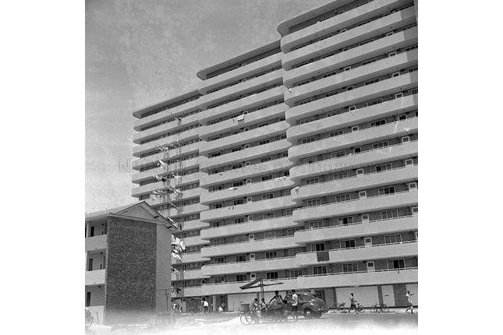

Fig. 1, The former Forfar House this actually looks nice from far away… nicer than a lot of newer blocks…(c. 1956. Image from National Archives of Singapore)

SIT’s Princess Estate project in Queenstown set the stage for the Housing Development Board (HDB) to complete the Duchess, Tanglin Halt, and Commonwealth districts in the early 1960s, which were built in similar style: Fig. 2 shows the view of the newly constructed Queenstown housing estate from afar.

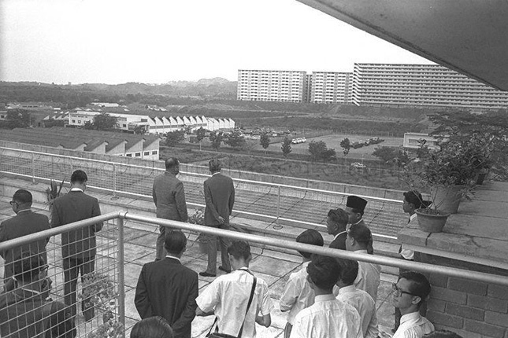

Fig. 2, Minister for National Development Lim Kim San briefing Yang di-Pertuan Agong Tuanku Syed Putra as he views Queenstown housing estate from the sixth storey of Princess House during his state visit to Singapore. (c. 11 November 1963. Image from National Archives of Singapore)

The modernist idea of the mass produced house was advocated by Le Corbusier in his designs in the 1910s and 20s – they were unlikely to be actually built but were more of a comment on industrialising the building process. In the 1970s, Europe was ending its post-war reconstruction phase, having “developed numerous prefabrication techniques to rebuild its cities”. Singaporean engineers were sent there to learn these techniques, which “proved indispensable to the HDB’s building programme, as it greatly reduced dependence on manual labour and increased site productivity” (Centre for Liveable Cities, Singapore 2015).

Modern city planning is often a part of total city planning, well, the idea of ‘total planning’ is definitely something that comes from the ‘modernist’ tradition. It’s the idea that an all-knowing planner can plan everything about a city. where nearly every aspect of public and private living – architecture, economy, functions of the city, human relationships – is theorized, engineered, and optimized through the city plan. This assumes two things: that there exists a unique solution to urban design,correct… and that there is a designer with complete knowledge of the problem, and the ability to obtain this solution and implement it (Scott 1998). Since its independence, Singapore has also developed with these assumptions in its “pure intention”: manifesting in “authored chaos”,? This part starts to get a bit confusing… you were talking about order and control so this transition seems a bit abrupt… “designed ugliness”, and “willed absurdity” (Koolhaas 1995). Superficially this can seem authoritarian, but the urgency of the situation is often a defence of the decision. Just after independence, mainstay entrepot trade stagnated, and Singapore faced sociopolitical unrest due to communist inspired conflicts in industrial relations (Low 1997). “In the first stage of public housing development, urgency to find a solution to the problem of housing shortage in Singapore did not allow time for research. Pragmatism prevailed…” (Wong and Yeh 1985). While it is often criticised, the modern city planning approach that Singapore adapted for use was fairly necessary at the time. So you agree with the conventional historical narrative that there were no other options? Since then, with the efficiency and results that the approach has produced, and because no other fundamentally alternative approach has any alternative actually been tried? This is off-topic a bit and does not factor into the mark for this assignment, but it might be worth thinking about places lik Taiwan, which is ‘Chinese’ like SG but seems to have a completely different politics but with sustained economic growth…will produce them at the same levels, Singapore has generally maintained a technocratic belief.

Since the 1950s, maybe since the 1980s if you are talking about historic preservation…. And even then it is a reflection of international trends... Singapore has arguably evolved its own flavor of modernist city planning, that isn’t strictly Corbusian. Good… In multicultural, multi-ethnic Singapore, retaining identity and cultural heritage is important to maintaining the integrity of the social fabric. Commercial and residential space are not the only spaces that have been optimized according to program: cultural conservation give concrete examples… has been institutionalized in the Singapore Heritage Board, religious centres are found along streets, the shophouse conservation project by the Urban Redevelopment Authority (URA) preserves the architecture of the past, and in doing so, preserves a historical reference and an identity for the Singapore people. Conservation is something that emerges after people complain about exactly the sort of ‘erasure’ that Scott talks about….Urban renewal strategies, though made easy through governance and the “thirty years of Tabula Rasa” that Koolhass refers to, are carefully planned so it was consciously modernist? Which sort of goes against what you seemed to be saying earlier… – “Contrary to common belief urban renewal does not imply wholesale demolition of blocks of obsolete buildings in order to rebuild the city on modern lines; an urban renewal programme is a failure if buildings of great historical or architectural merit are not retained along with the programme of rehabilitation of areas with special character” (Sun 1973). While Singapore, at a distance, seems like a exemplification of the high-modernist city in planning and in architecture, a closer examination reveals a city planning approach that is sensitive and sentimental to some extent. This is an interesting claim, but it requires some sort of support beyond just mentioning the preservation of shophouses, etc. Its not impossible case to make, but it does require a bit of ‘research’….Of course, a critique could be that this sentimentalism is merely functional and serves to further political agendas, well, yes… the preservation that is successful often only reinforces the conventional narrative of history or it advances tourism… which arguably makes the Singaporean approach seem more elitist, authoritarian and technocratic than it actually is. When you bring up a potential counterpoint to your position, it’s good to discuss it a bit so the reader can have some basis to evaluate the issue.

In the final analysis, Singapore has generally taken a modern approach to city planning out of necessity. It would have been good to incoropate some of Loh Kah Seng’s argument here… do you think he thinks it was necessary or if it was convenient political strategy? You may be right, but if you know there is a counter argument covered in class materials, it’s a good idea to reference it and then try to refute it or see if it changes your arguement in any way. Modern city planning principles have built Singapore economically from third-world to first, and I would like to think Le Corbusier would have jumped out of his grave at the opportunity of designing for a city like early post-independence Singapore. However, Singapore faces its unique set of constraints – land size, cultural confluence, being a relatively youthful nation – and like even Koolhaas admits, should be read “on its own terms”.

Overall, this is a good attempt at answering the question. There are some parts that are good and clear, but also parts that are not as well supported. There also seem to be some points that contradict each other so it’s a bit difficult in the middle of the essay to know where you are headed – a defense of modernism in Singapore or something else… 87

**Bibliography**

Centre for Liveable Cities, Singapore. 2015. *Urban Systems Studies: Built by Singapore: From Slums to a Sustainable Built Environment.* Singapore: Centre for Liveable Cities, Singapore.

CIAM, Congress Internationaux d'Architecutre Moderne. 1933. *La Charte d'Athenes.* Paris: The Library of the Graduate School of Design, Harvard University, 1946.

D'Hooghe, Alexander. 1973. *The Liberal Monument: Urban Design and the Late Modern Project.* New York: Princeton Architectural Press.

Koolhaas, Rem. 1995. "Singapore Song Lines." In *S, M, X, XL*, 1011-1037; 1075-1087. New York: The Monocelli Press.

Liu, Thai Ker. 1973. "Reflections on Problems and Prospects in the Second Decade of Singapore's Public Housing." In *Planning in Singapore: Selected Aspects & Issues*, by Chua Peng Chye, 22-31. Singapore: Chopmen Enterprises.

Low, Linda. 1997. "The Political Economy of the Built Environment Revisited." In *City and the State: Singapore's Built Environment Revisited*, by Giok Ling Ooi and Kenson Kwok, 78-103. Singapore: Oxford, The Institute of Policy Studies.

Scott, James. 1998. "The High Modernist City." In *Seeing Like a State: How Certain Schemes to Improve the Human Condition Have Failed*, 104. New Haven: Yale University Press.

Sun, Chew Chee. 1973. "Key Elements in the Urban Renewal of Singapore." In *Planning in Singapore: Selected Aspects and Issues*, by Chua Peng Chye, 35. Singapore: Chopmen Enterprises.

Wong, Aline K., and Stephen H.K. Yeh. 1985. *Housing a Nation: 25 Years of Public Housing in Singapore.* Singapore: Housing and Development Board/Maruzen Asia.